Student Name: Yuyang Gong Student Number: 49079984 Team Name: FriendZone
Week: 3
Title: Interviewing Residents About Social Connection

Description:
The interviews showed that new residents often begin with small, situational conversations: meeting a roommate, speaking in a kitchen or lift, asking about study, or attending an accommodation event. Shared interests and repeated encounters make interaction easier, while language confidence, established friendship groups, busy schedules and fear of awkwardness can prevent participation.
A recurring insight was that quieter residents are not necessarily unwilling to socialise. They may need more time, a patient conversational partner and a shared activity that removes the pressure of introducing themselves without context. Maintaining contact also depended on a mutual reason to meet again rather than on exchanging contact details alone.
Visual Evidence:
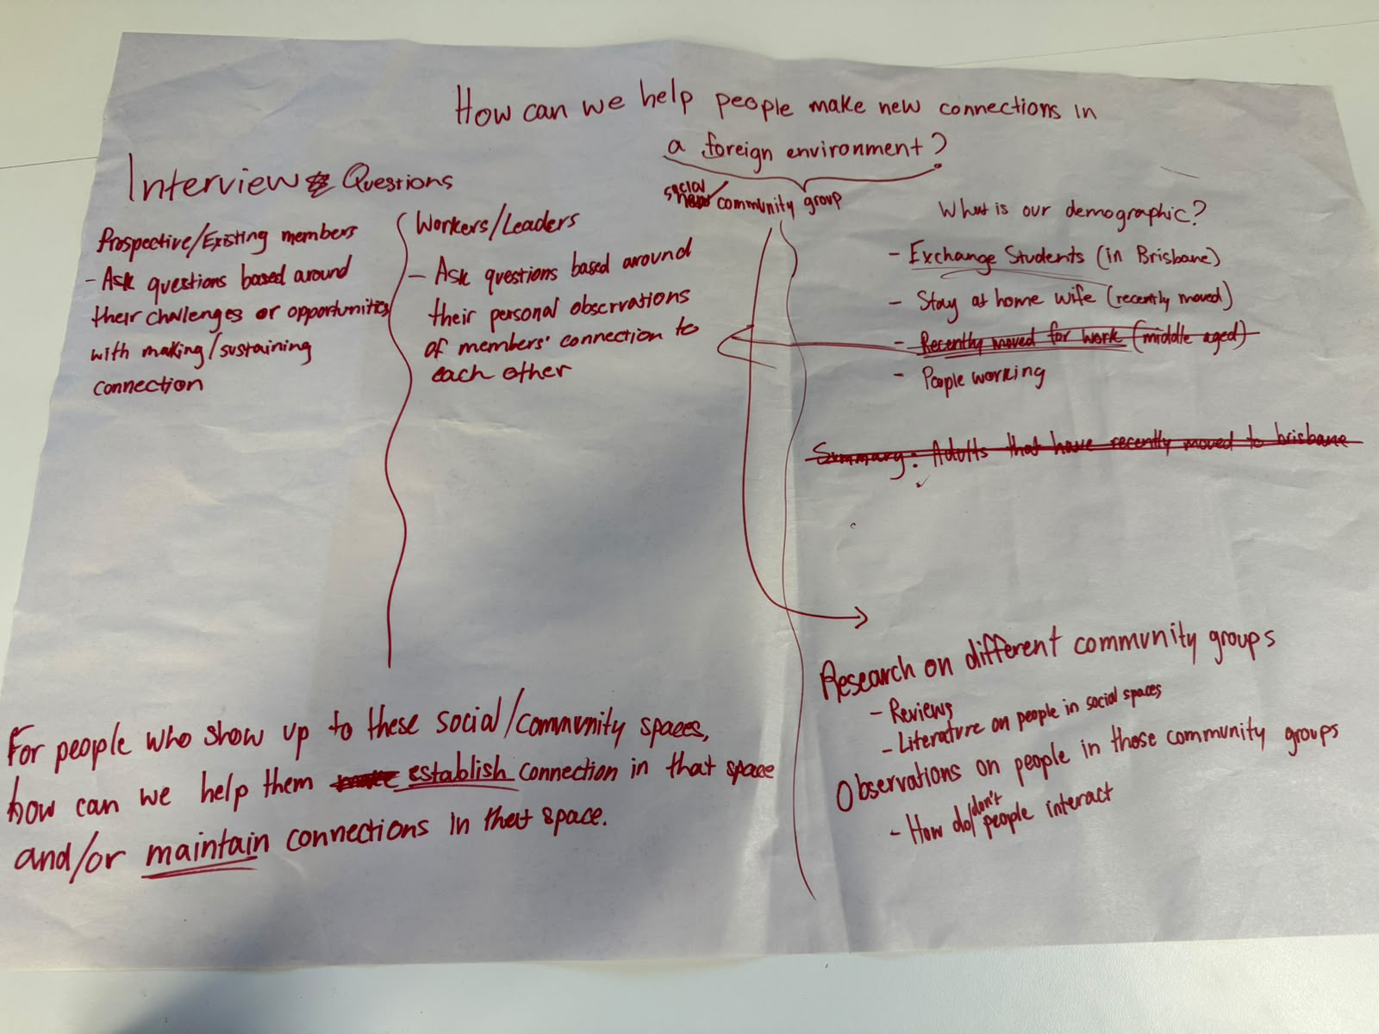
Interview question development focused on community spaces, barriers and continued contact.
Statement on Learning:
I learned to distinguish visible behaviour from motivation. Someone who appears quiet may be interested but uncertain, busy or communicating in a second language. This changed our design focus from pushing participation toward creating safer entry points, manageable group sizes and reasons for repeated interaction.

